Testing & Results:

Tests went as expected. For starters, switches 15 to 12 were each used to select binary numbers. If a switch was in the off/downward position, that meant that the digit that lines up with that switch would be 0. If a switch was in the on/upward position, that meant that the digit that lines up with that switch would be 1. Whatever the configuration of the numbers ends up being, pertaining to each switch position, is the 4-bit binary representation on the seven segment display. In correspondence on the left hand side of the display, there are lights that are on the right which turn on/off depending on what digits are being used on the left side. If one of those switches associated with those lights are toggled, the system produces an error with an “apostrophe” symbol. Figures below are shown for interpretation.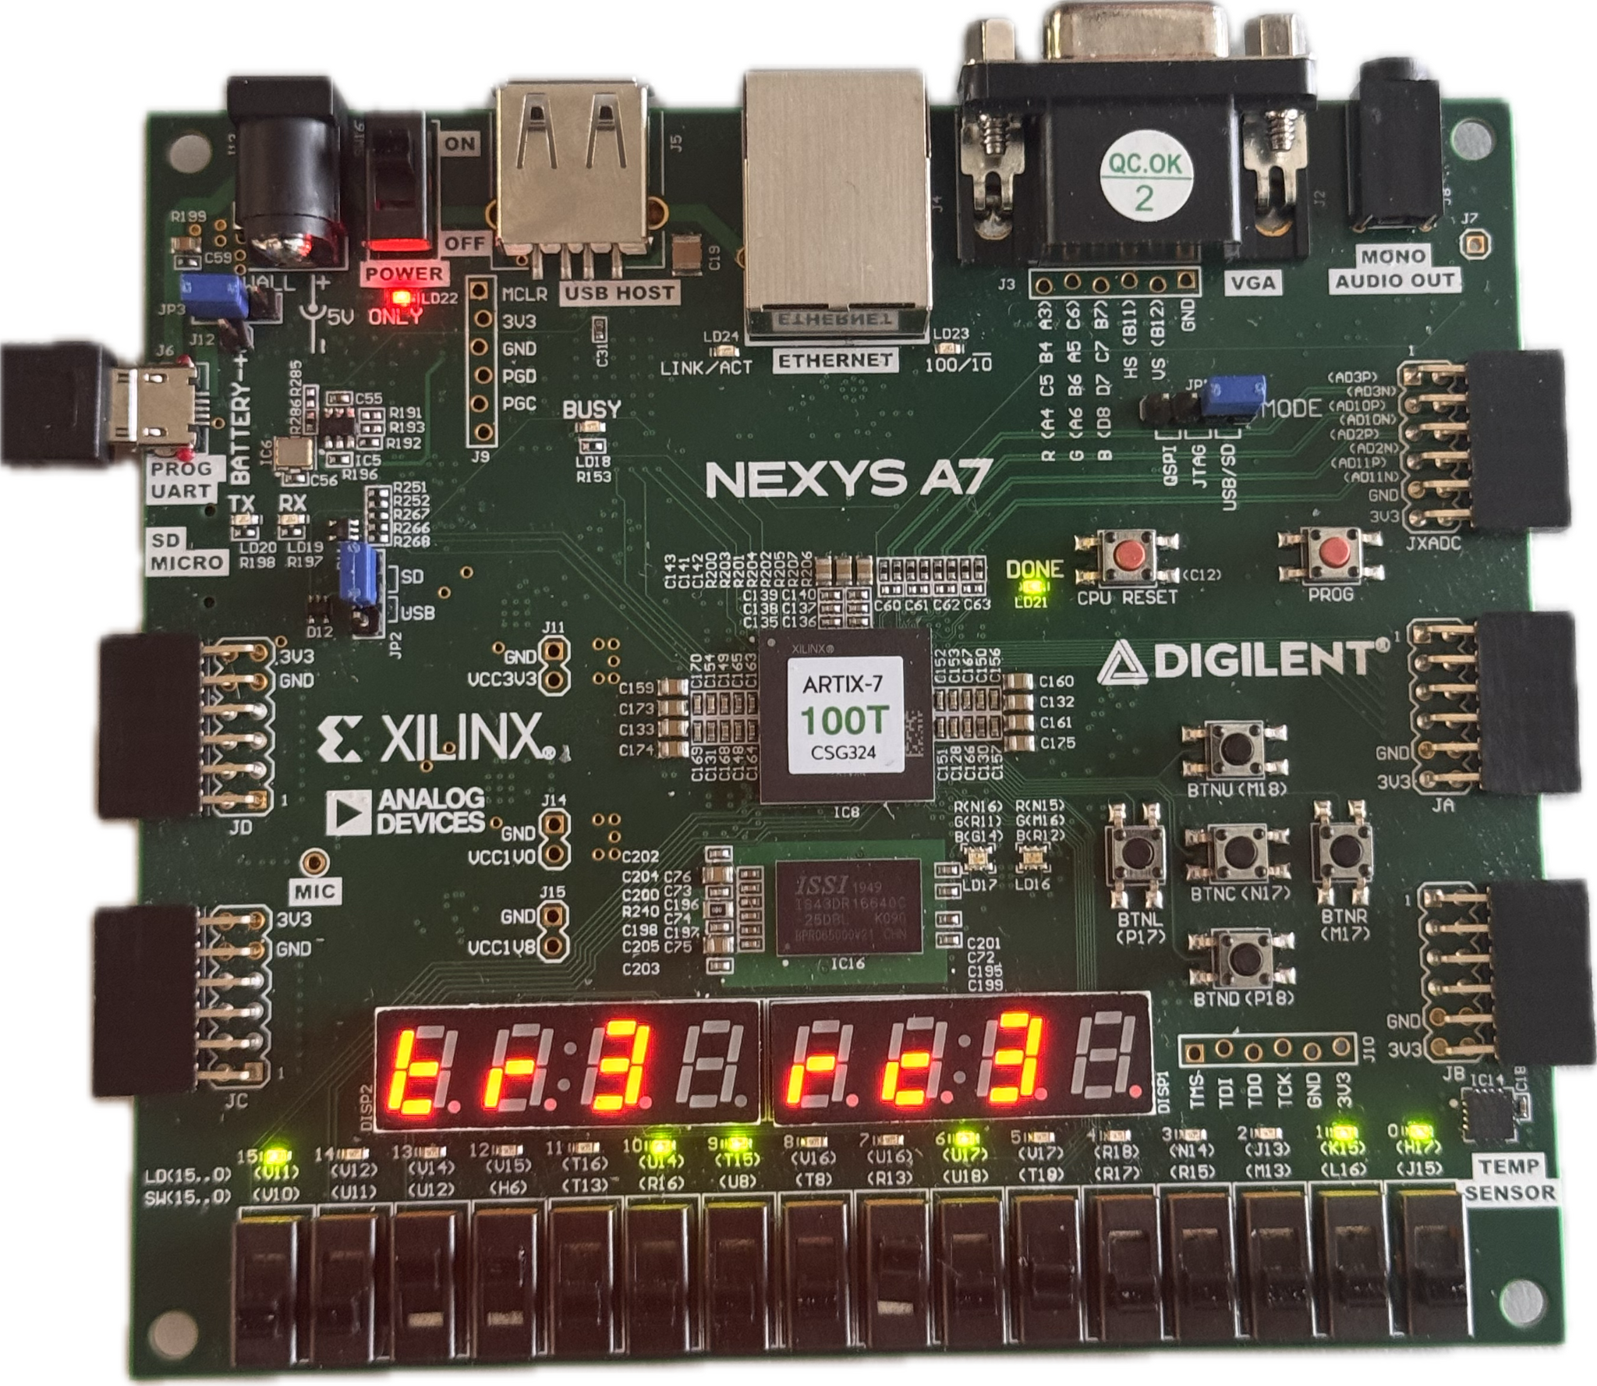

Figure 1: Binary 3 represented through switches 12 & 13 in the upward positions to make 0011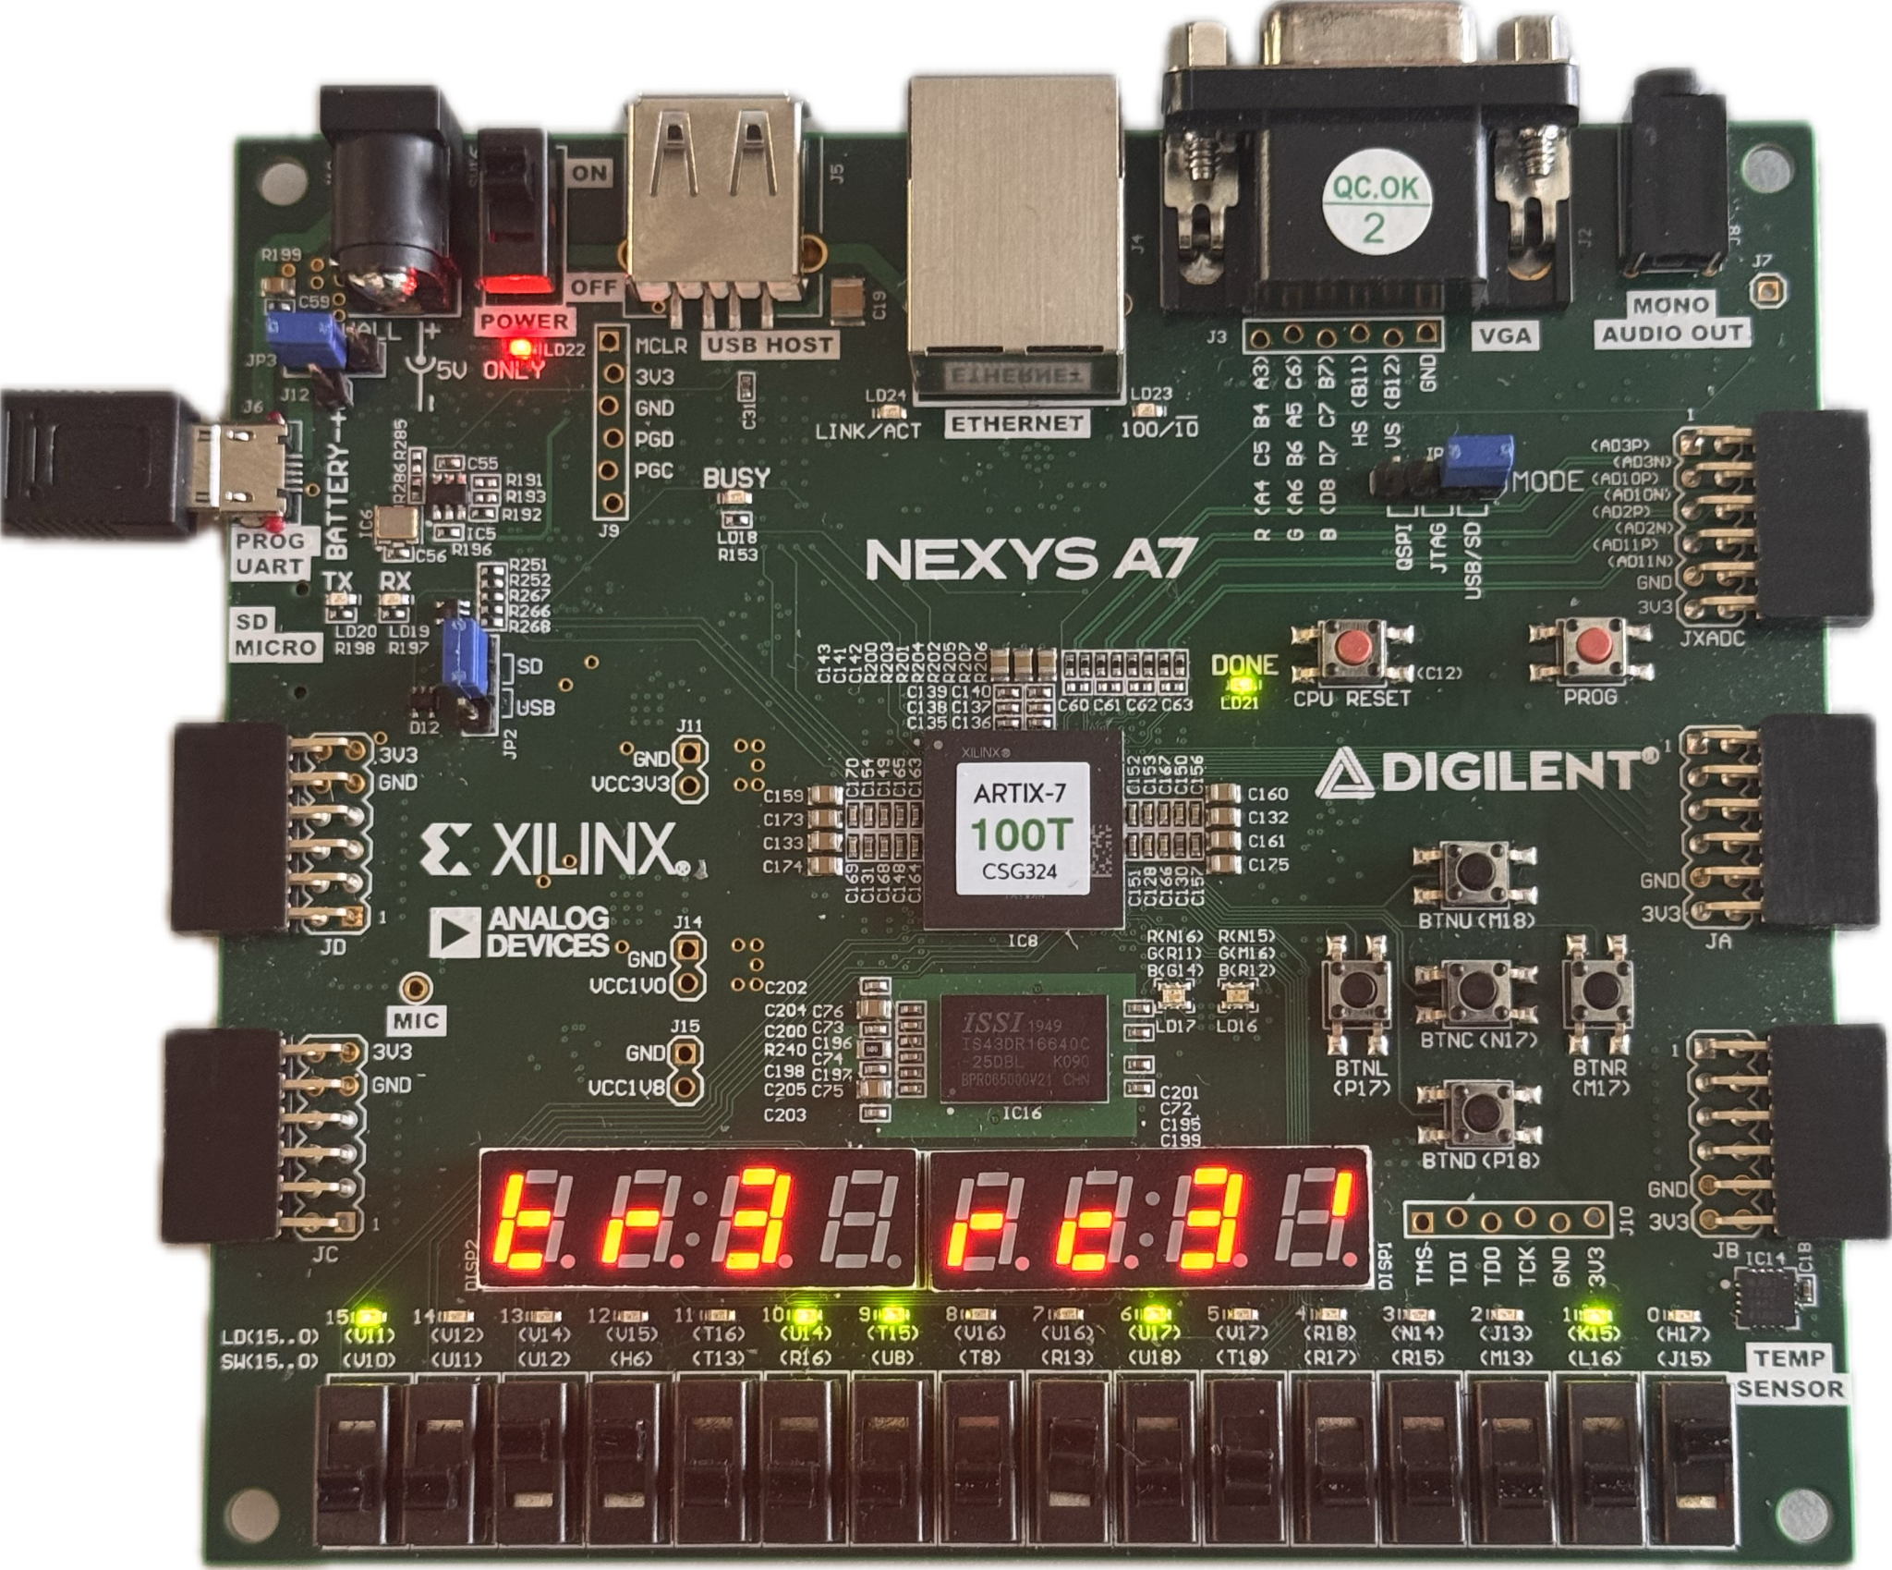

Figure 2: Binary 3 represented through switches 12 & 13 in the upward positions to make 0011

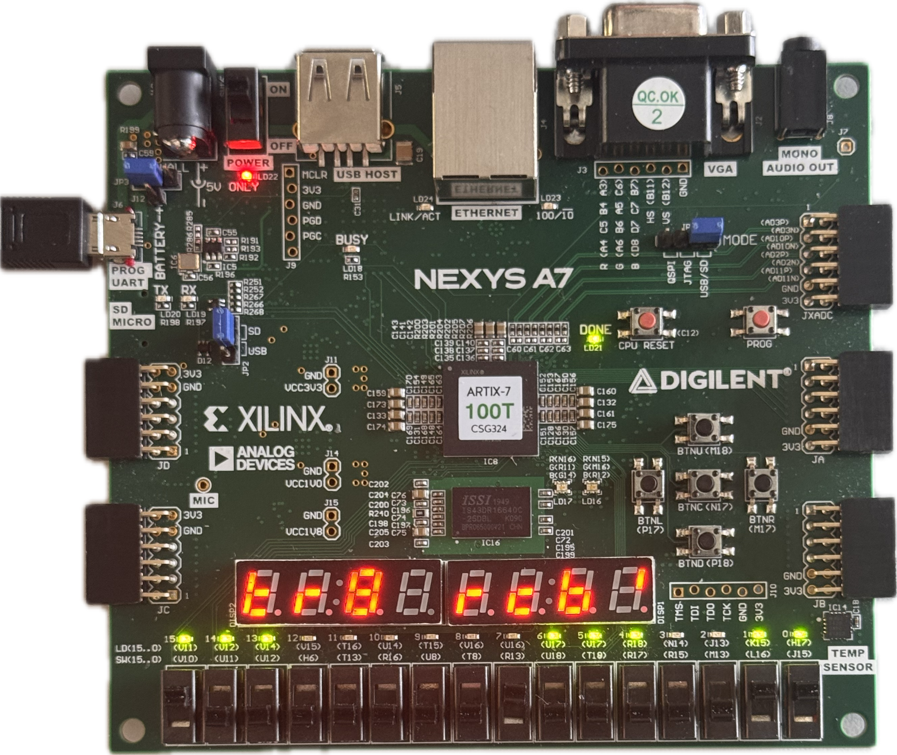

Figure 3: Received signal changes when there is more than one error

Discussion & Conclusion:

All in all, Lab 7 was a success. Going over things one more time, Hamming Code implementation was done to make an error detecting module that instantiates not only in the code, but on the seven segment display. Parity checks were utilized to add redundancy to data in order to catch single digit issues within a given binary value. A 16 row long table was made to test all of the different possibilities for each digit in a given 4 bit binary number. That table was then used to make case statements for the error detector and injector. This was then applied to the Nexys A7-100Ts switches, LEDs, and seven segment display.